 Welcome to

Deliverance Center

*A Bible Preaching Church since 1967*

*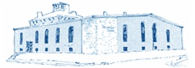*

1008 Congress Street Portland, Maine 04102

SCHEDULE OF SERVICES:

* Sunday School…10 a.m.
* Sunday Morning….11 a.m.
* Sunday Evening…..6:30 p.m.
* Wednesday Bible Study…7 p.m.
* Friday Youth Meeting….6 p.m.
* Saturday Teen Meeting….6 pm.

(the last Saturday of each month)

* Street Meetings….Daily at 5 p.m.

www.deliverance.me

207-774-8192

Pastor: Rev. Stephen G. Reynolds, Sr.

Assistant Pastor: Rev. Stephen G. Reynolds, Jr.



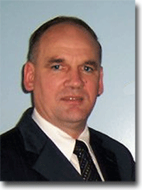 Pastor Rev. Stephen G. Reynolds, Sr. come to Portland at six years of age with his father Rev. James R. Reynolds, Sr. For over 40 years he worked side by side with his father at Deliverance Center and its various ministries. In 2012, Rev. Stephen Reynolds, Sr. was honored to take the pastor-ship at Deliverance Center.

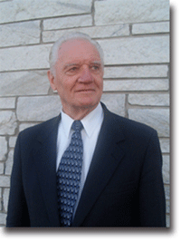 The late Rev. James R. Reynolds, Sr., founded the Deliverance Center in 1967, with the aid of several volunteers. In time, Rev. Reynolds' own family members have become a part of daily functions at the Deliverance Center along with several very dedicated volunteers.

Initially, the Deliverance Center helped and worked for the transformation of alcoholics and drug addicts. This focus is especially seen in its name, as being a place of deliverance from alcoholism or drug addiction.

The Deliverance Center was also established as a local church at that time.

Then, in 1969, it expanded to include an educational facility. The first of its schools, Deliverance Bible Institute, was established to train young adults for Christian service in a three-year course.

We are a Bible believing church located off the I-295 Exit 5A ramp headed  towards downtown Portland Maine.

“It is the

Mission

of Deliverance Center to

preach and teach

the gospel as Jesus did

& to

live

the gospel as Jesus lived it.”

Tenets of Faith

We Believe:

1. In the plenary inspiration of Scripture.

2. In the absolute Trinity of the eternal Godhead.

3.   In the pre-existence and deity of our Lord Jesus Christ.

4.    In the personality and deity of the Holy Spirit.

5.   In the vicarious atonement through the death and resurrection of our Lord.

6.    In complete salvation by grace through faith.

7.    In the life of holiness without which no man shall see the Lord.

8.    In water baptism by immersion.

9.    In the observance of the Lord’s Supper.

10.   In tithing as God’s financial plan for the church.

11.   In the Bible revelation of Divine healing.

12.   In the personal Baptism of the Holy Ghost as received by the Apostles.

13. In the gifts of the Holy Ghost.

14.  In the Church, which is the Body of Christ composed of spirit-filled Believers.

15. In a four-fold ministry to the Church for the perfecting of the Saints.

16.  In the Bride of Christ which is composed of Overcomers out of the Body of the Church.

17.  In the personal and imminent return of our Lord.

18.  In the everlasting punishment of the impenitent.

19.  In eternal life for all true Believers.

20.  In the millennial reign of Christ.